Sales partner Mieth honored by LAUDA once again

Reliability and growth recognized

Lauda-Königshofen, April 12, 2024 – LAUDA DR. R. WOBSER GMBH & CO. KG, the world leader in precise temperature control, has presented Mieth GmbH Labor- und Messtechnik with the LAUDA Honor Award as the “Most successful regional representative in 2023” for its consistent sales success and resilient growth over the past year.

Mieth has made remarkable progress since its foundation by Klaus-Peter Mieth in 1990. The sales agent was transformed into a GmbH with a total of three employees in 2001. The company was successively developed both geographically and organizationally in the years that followed. Despite the premature death of Klaus-Peter Mieth in 2010 at the age of only 53, the company has continued on its successful course under the management of his son Johannes Mieth and has grown even under difficult market conditions. Today Mieth GmbH is an established and professional sales partner of LAUDA with nine employees.

Started as a sales agent for Saxony, the company has developed into a permanent and reliable fixture in the LAUDA sales strategy and also looks after the territories of Berlin, Brandenburg and Mecklenburg-Western Pomerania in the meantime. Mieth GmbH was honored by LAUDA as the most successful sales agent in Germany in 2006 and 2017– a confirmation of the constant adaptation to market changes and the pursuit of improved customer service. Mieth GmbH generated impressive sales of more than two million euro in 2023, which is attributable to a healthy trading business as well as comprehensive services such as the repair, maintenance and testing of laboratory and measuring technology. The company also follows carefully directed long-term strategies with a view to sustaining its success.

“This new award is a confirmation of our work. It's the result of our systematic customer-oriented approach and our professional team, which I'm extremely proud of. The support and know-how of Stefan Kühn in the back office are indispensable and the performance of all the employees is a key success factor. Together, we will also do our best to offer our customers the best possible service in the future“, said the delighted managing director, Johannes Mieth, who accepted the Award in the presence of Andreas Aiblinger, Head of DACH Sales and Service, and the President and CEO, Dr. Gunther Wobser.

The business relationship between LAUDA and Mieth GmbH has developed into a real partnership over the years. Mutual respect and the shared goals of long-term cooperation and continuous improvement are at the forefront here. Dr. Wobser also confirmed this development: “Mieth GmbH has established itself as a reliable partner of LAUDA which shares our values and actively contributes to the further development of our company. I would like to congratulate Johannes Mieth and the entire team on this outstanding achievement and would particularly like to thank them for their long-standing and loyal partnership. It's a pleasure to work together with such a dedicated and resourceful partner like Mieth GmbH, and we look forward to continuing our shared success story.“

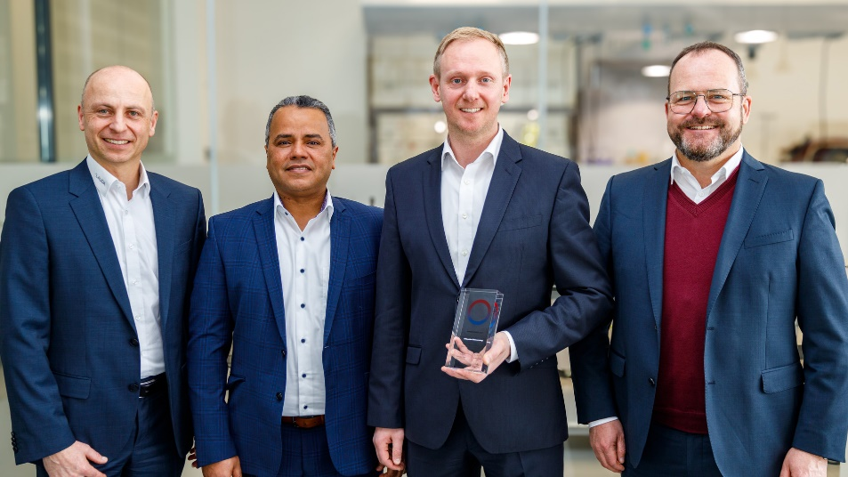

Image: From left to right: Andreas Aiblinger, Head of DACH Sales and Service of LAUDA, Dr. Mohatmed Becker, Head of Sales Field Service Germany of LAUDA, Johannes Mieth, Managing Director of Mieth GmbH Labor- und Messtechnik, and the President and CEO of LAUDA, Dr. Gunther Wobser. © LAUDA

We are LAUDA – the world leader in precise temperature control. Our constant temperature equipment and systems are at the heart of important applications, contributing to a better future. As a complete one-stop supplier, we guarantee the optimum temperature in research, production and quality control. We are the reliable partner for electromobility, hydrogen, chemicals, pharmaceuticals/biotech, semiconductors and medical technology. We have been inspiring our customers for almost 70 years with our expert mentoring and innovative solutions – every day anew and all over the world.

In our company, we always go one step further. We support our employees’ development and are constantly developing ourselves: to create a better future together.

Press contact
We are more than happy to make prepared information about our company, the LAUDA Factory Gallery and our projects in the area of innovation promotion, digitalization and idea management available to the press. We look forward to hearing from you – just give us a call!

CHRISTOPH MUHR
Head of Corporate Communications
T + 49 (0) 9343 503-349
christoph.muhr@lauda.de

LAUDA DR. R. WOBSER GMBH & CO. KG, Laudaplatz 1, 97922 Lauda-Königshofen, Deutschland/Germany. Limited partnership: Headquarters Lauda-Königshofen, Registration court Mannheim HRA 560069. General partner: LAUDA DR. R. WOBSER Verwaltungs-GmbH, Headquarters Lauda-Königshofen, Registration court Mannheim HRB 560226. Managing Directors: Dr. Gunther Wobser (President & CEO), Dr. Mario Englert (CFO), Dr. Ralf Hermann (CSO), Dr. Marc Stricker (COO)

