ALL EYES ON GROWTH

LAUDA achieves record turnover

Lauda-Königshofen, February 24, 2023 – LAUDA DR. R. WOBSER GMBH & CO. KG closed 2022 with record turnover. With a consolidated group turnover of around EUR 121 million, the global market leader exceeded the original target of EUR 120 million by EUR 1 million, and for the first time in it's history, was able to announce a turnover of more than EUR 100 million. In addition, the LAUDA Group also closed the month of December with a record turnover of around EUR 15.56 million. This record is the result of the comprehensive Drive250 strategy project, which LAUDA has been pushing forward for a year now. The family-owned company has set itself ambitious growth targets with a new structure, future-oriented investments and process optimizations: By 2026, the number of LAUDA employees is set to almost double internationally, from 530 at present to over 1,000. Turnover is expected to increase from the current level of around 120 million euro to 250 million euro in the five-year period under consideration. The 2022 record clearly shows that the strategy of the global market leader is working and that everything is going according to plan in terms of content. This is particularly remarkable given the geopolitical and socio-political backdrop of the previous year.

"We have made amazing progress since the implementation of our Drive250 strategy project," explains President & CEO of LAUDA, Dr. Gunther Wobser. "As a result, we hired almost 60 new employees in 2022." In spite of a year full of unpredictability, the company managed to stay on course. "2022 was extraordinary in every respect and was extremely demanding for everyone at LAUDA. It was characterized by large volumes of incoming orders, material shortages and bottlenecks." Nevertheless, LAUDA was still able to pursue its ambitious goals. The success of the company is also down to the performance of its employees: "I would like to thank everyone who contributed to this outstanding result and I am sure that we will achieve our goals together again this year," concludes Dr. Gunther Wobser.

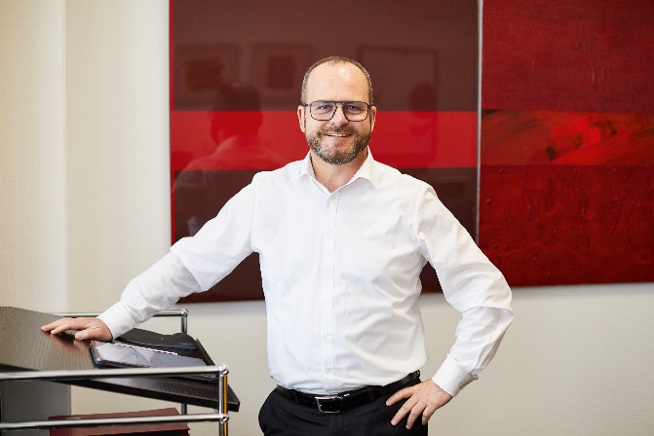  Fig. 1: Dr. Gunther Wobser, President & CEO of LAUDA © Behrendt and Rausch | 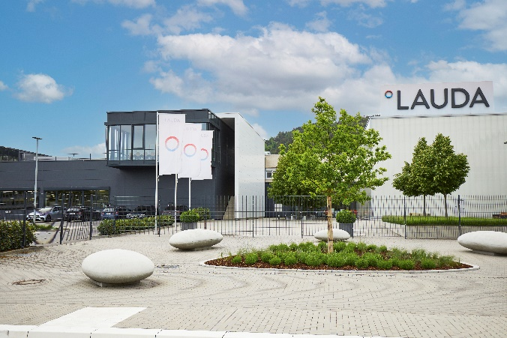  Fig. 2: LAUDA DR. R. WOBSER GMBH & CO. KG, © Behrendt and Rausch

We are LAUDA – the world leader in precise temperature control. Our constant temperature equipment and systems are at the heart of important applications, contributing to a better future. As a complete one-stop supplier, we guarantee the optimum temperature in research, production and quality control. We are the reliable partner for electromobility, hydrogen, chemicals, pharmaceuticals/biotech, semiconductors and medical technology. We have been inspiring our customers for more than 65 years with our expert mentoring and innovative solutions – every day anew and all over the world.

In our company, we always go one step further. We support our employees’ development and are constantly developing ourselves: to create a better future together.

Press contact
We are more than happy to provide the press with prepared information about our company and especially about our projects on the issues of environmental protection and sustainability. We will be pleased to arrange interviews with our management about these issues. We look forward to hearing from you – just give us a call!

CLAUDIA HAEVERNICK
Head of Corporate Communication
T + 49 (0) 9343 503-349
claudia.haevernick@lauda.de

