STRONG AXIS FROM BURGWEDEL TO LAUDA-KÖNIGSHOFEN

LAUDA – Global market leader for precision temperature equipment celebrates successful production in branch office

Lauda-Königshofen, 6 February, 2023 – The groundbreaking strategy project Drive250 by LAUDA DR. R. WOBSER GMBH CO. KG based in Baden-Württemberg continues to move forward at full speed. LAUDA's Drive250 project is setting the course for the future, which is also proving important for the town of Burgwedel in the Hanover region, where the global market leader for precision temperature equipment has a branch office. LAUDA used the "Drive250 Stopover" get-together format to bring together employees from both locations to celebrate what has been achieved so far, share information about the current progress of the processes, and examine common objectives. For this reason, President & CEO, Dr. Gunther Wobser, traveled to Burgwedel with his colleague, CFO, Dr. Mario Englert. The mayor of Burgwedel, Ms. Ortrud Wendt, was the guest of honor: "My goal is to maintain a close relationship with the companies based here at the industrial location of Burgwedel, and provide a local connection to the city administration. This is why I was particularly happy to accept the invitation from the LAUDA management to visit the company in Grossburgwedel. In discussions with President & CEO, Dr. Gunther Wobser, and CFO, Dr. Mario Englert, we exchanged views on ways of promoting the mobility revolution and the use of renewable energy, among other things. It's a good thing that LAUDA is here and I hope that the company will remain at this location for many years to come."

The former laboratory specialist GFL officially became part of the LAUDA Group at the beginning of 2019, and LAUDA Burgwedel was fully integrated in its parent company in 2022. The family-owned company is setting itself ambitious growth targets with a new structure, future-oriented investments and process optimizations. In this regard, new employees will be recruited and a large number of jobs created both at the headquarters in Lauda-Königshofen and Burgwedel, as well as other international locations – the number of LAUDA employees worldwide is planned to almost double by 2026, from 580 at present to over 1,000. Turnover is expected to increase from the current level of around 120 million euro to 250 million euro in the five-year period under consideration. To this end, the company is investing an amount well into the double figure millions for expansion of the production and logistics, but also for administration, IT and digitalization. The intensification of the business development in the area of future technologies such as hydrogen will also play an important role.

At the event, the management also drew a positive conclusion of the Drive250 strategy project, which was launched at LAUDA in the first quarter of 2022. In his speech, Dr. Gunther Wobser dubbed the past year as a "year of growing together". In addition to mutual visits between Burgwedel and Lauda-Königshofen, working groups were defined to systematically address the individual areas, processes and challenges. Here, the main focus was placed on mutual understanding and support, generating profits together, and improving productivity and performance. Consequently, sales were stabilized, the introduction of the LAUDA ERP system started, and the hardware and software equipment at location was upgraded. The hurdles for NRTL approval of the LAUDA Versafreeze deep-freezers have also been overcome, making it possible to start sales in the USA. Turnover was 10 percent higher than in the previous year, while the overall profit at the Burgwedel site was 80,000 euro. "Drive250 was a huge success last year, which we all worked on together, and I'm very happy to be able to start off the new year in this way," said Dr. Gunther Wobser.

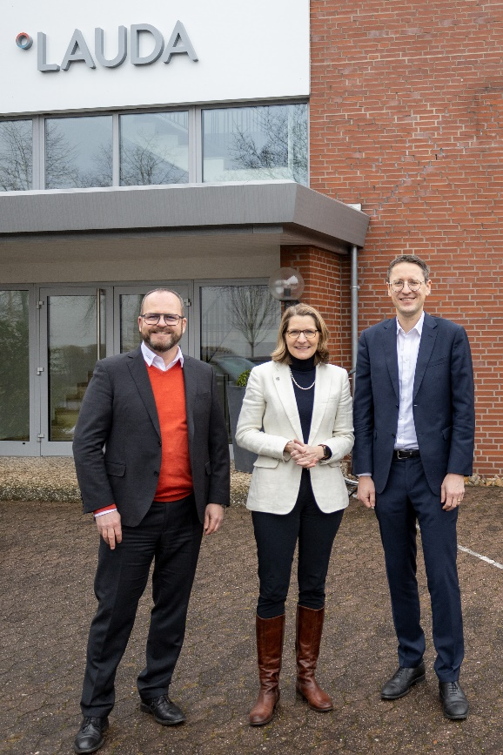
From left to right: The President & CEO of LAUDA, Dr. Gunther Wobser, mayor of Burgwedel, Ms. Ortrud Wendt, CFO of LAUDA, Dr. Mario Englert © LAUDA

We are LAUDA – the world leader in precise temperature control. Our constant temperature equipment and systems are at the heart of important applications, contributing to a better future. As a complete one-stop supplier, we guarantee the optimum temperature in research, production and quality control. We are the reliable partner for electromobility, hydrogen, chemicals, pharmaceuticals/biotech, semiconductors and medical technology. We have been inspiring our customers for more than 65 years with our expert mentoring and innovative solutions – every day anew and all over the world.

In our company, we always go one step further. We support our employees’ development and are constantly developing ourselves: to create a better future together.

Press contact
We are more than happy to provide the press with prepared information about our company and especially about our projects on the issues of environmental protection and sustainability. We will be pleased to arrange interviews with our management about these issues. We look forward to hearing from you – just give us a call!

CLAUDIA HAEVERNICK
Head of Corporate Communication
T + 49 (0) 9343 503-349
claudia.haevernick@lauda.de

