SUSTAINABLE SITE EXPANSION

LAUDA is building a new parking lot with a photovoltaic system

Lauda-Königshofen, Germany, February 27, 2023 – The further expansion of the LAUDA DR. R. WOBSER GMBH & CO. KG company premises at the Lauda-Königshofen site was launched with an official groundbreaking ceremony. 180 new parking spaces are being built for the rapidly growing team of LAUDA employees. The parking spaces are being built directly on the company premises and will be canopied with a modern photovoltaic system to maximize use of the site. In addition to the LAUDA management and Works Council Chairman Elmar Mohr, the mayor of the city of Lauda-Königshofen, Dr. Lukas Braun, and representatives of property developer Faul + Bethäuser and Sparkasse Tauberfranken also attended the groundbreaking ceremony on February 16. President, CEO and advisory board member Dr. Gerhard Wobser also took part in the groundbreaking ceremony held to mark the start of the construction work.

The new parking lot is not only intended to provide parking for the growing number of employees that have joined the company over the past year: President & CEO, Dr. Gunther Wobser, explained in his speech "It's not just about providing parking for cars, it's about sustainability, the careful use of resources, and our responsibility as a company." LAUDA has set itself and its employees the task of making an important contribution to environmental protection as a company. In addition to the installation of a roof-mounted photovoltaic system and charging infrastructure for electric cars that can also be used by the public, the family business was one of the first companies in Germany to make the company car fleet accessible to the public with a car sharing solution. Covering the parking lot with a photovoltaic system is another logical step in helping the company achieve its ambitious goal of becoming climate-neutral by 2030. Furthermore, the family business will also soon have its own bus stop.

The construction project will create another 90 parking spaces, doubling the capacity of the previous site in the west to a total of 180. 100 of these parking spaces will be covered. Scheduled to start up by September 2023, the photovoltaic system installed on the canopies above the parking spaces will generate 350 kWp of power, thereby covering around 30 percent of LAUDA's electricity requirements. The global market leader is investing around another 1.2 million euro in this expansion project.

The mayor of Lauda-Königshofen, Dr. Lukas Braun, paid tribute to the growth strategy of the global market leader: "The structural expansion of the Lauda-Königshofen site is a clear demonstration of the company's commitment to the region." According to Dr. Lukas Braun, the construction of the parking lot can also be seen as a sign of further growth. Plans to expand the site further north toward Distelhausen are already in the pipeline.

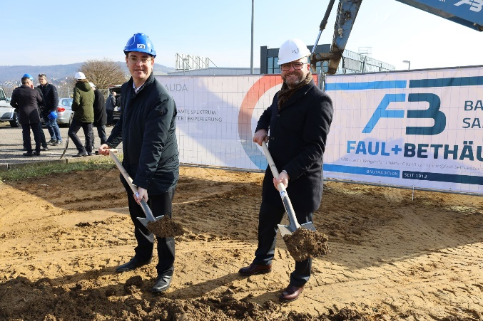  The President & CEO of LAUDA, Dr. Gunther Wobser (right), with Lauda-Königshofen mayor, Dr. Lukas Braun, at the groundbreaking ceremony at LAUDA company headquarters. © Robert Horn/LAUDA | 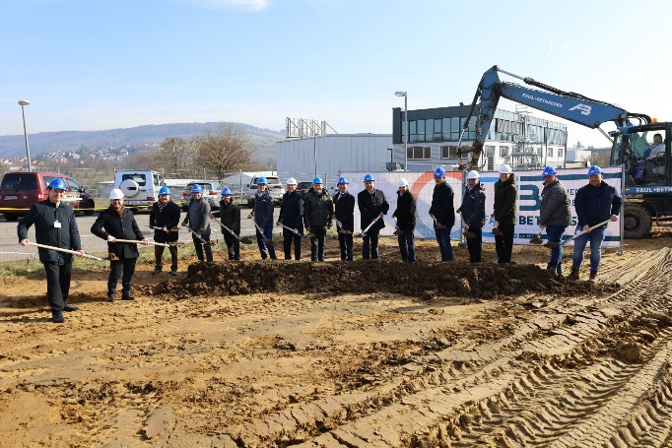  Official groundbreaking ceremony at LAUDA for the construction of the new parking lot with photovoltaic canopy, attended by the President & CEO, Dr. Gunther Wobser (second from left), and mayor, Dr. Lukas Brown (left). © Robert Horn/LAUDA

We are LAUDA – the world leader in precise temperature control. Our constant temperature equipment and systems are at the heart of important applications, contributing to a better future. As a complete one-stop supplier, we guarantee the optimum temperature in research, production and quality control. We are the reliable partner for electromobility, hydrogen, chemicals, pharmaceuticals/biotech, semiconductors and medical technology. We have been inspiring our customers for more than 65 years with our expert mentoring and innovative solutions – every day anew and all over the world.

In our company, we always go one step further. We support our employees’ development and are constantly developing ourselves: to create a better future together.

Press contact
We are more than happy to make prepared information about our company, the LAUDA Factory Gallery and our projects in the area of innovation promotion, digitalization and idea management available to the press. We look forward to hearing from you – just give us a call!

CLAUDIA HAEVERNICK
Head of Corporate Communication
T + 49 (0) 9343 503-349
claudia.haevernick@lauda.de

