RECOGNITION OF FLYING START

Italian agency DELO receives LAUDA Award

Lauda-Königshofen, November 04, 2022 – LAUDA DR. R. WOBSER GMBH & CO. KG has awarded the LAUDA Award for exceptionally successful new agencies to the Italian technology service provider DELO Instruments S.R.L. The award was presented at the DELO headquarters in Fizzonasco, south of Milan, on October 28. President & CEO of LAUDA, Dr. Gunther Wobser, personally handed over the award to Claudio Baldi, Founder and CEO of DELO Instruments.

“In the last four years, the collaboration between LAUDA and DELO has developed beautifully in the area of battery testing for the northern Italian automotive sector,” explains Antonio Manconi, Managing Director of LAUDA Italia, who is responsible for the direct collaboration with the Italian partner. “By marketing LAUDA constant temperature equipment to reputable manufacturers of vehicles and components in Italy, DELO has been able to achieve outstanding results. Our goal is to further expand the business and to support customers in the automotive industry with optimal temperature control solutions for complex test scenarios.”

“With LAUDA Italia S.R.L. and Managing Director Antonio Manconi ,we have built up a strong organization in Italy that has quadrupled our market share to around 40 percent, since it was first founded in 2014,” adds Dr. Gunther Wobser. “DELO Instruments has been a reliable partner at our side since 2018. Thanks to the support of our international agencies, electric mobility is one of LAUDA’s fastest-growing areas of business activity. That’s why we would like to thank our new agency, DELO, for a fantastic year in 2021 with this award.”

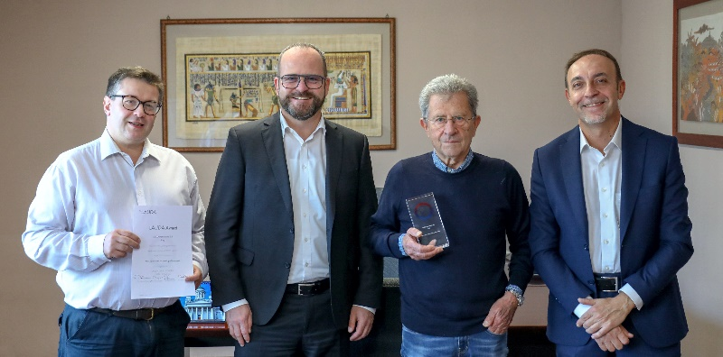
Award ceremony in Italy: Dino Delbue, Sales Manager at DELO, Dr. Gunther Wobser, President & CEO of LAUDA, Dr. Claudio Baldi, Founder and CEO of DELO, and Antonio Manconi, Managing Director of LAUDA Italia (left to right) Photo: LAUDA

We are LAUDA – the world leader in precise temperature control. Our constant temperature equipment and systems are at the heart of important applications, contributing to a better future. As a complete one-stop supplier, we guarantee the optimum temperature in research, production and quality control. We are the reliable partner for electromobility, hydrogen, chemicals, pharmaceuticals/biotech, semiconductors and medical technology. We have been inspiring our customers for more than 65 years with our expert mentoring and innovative solutions – every day anew and all over the world.

In our company, we always go one step further. We support our employees’ development and are constantly developing ourselves: to create a better future together.

Press contact
We are more than happy to make prepared information about our company, the LAUDA Factory Gallery and our projects in the area of innovation promotion, digitalization and idea management available to the press. We look forward to hearing from you – just give us a call!

ROBERT HORN CLAUDIA HAEVERNICK
Corporate Communication Head of Corporate Communication
Tel. +49 9343 503-162 Tel. +49 9343 503-349
robert.horn@lauda.de claudia.haevernick@lauda.de

