SHAPING INNOVATION REGIONALLY
LAUDA new cooperation partner of Innovationsregion Hohenlohe

Lauda-Königshofen, July 13, 2022 - LAUDA DR. R. WOBSER GMBH & CO. KG is a new cooperation partner of the association Innovationsregion Hohenlohe e. V. In this way, the global market leader wants to strengthen its own innovation activities and also supports the securing of locations and structural promotion in the extended region. Both partners want to use synergies and work together to promote and retain skilled workers in so-called MINT professions.

"As a family business with strong roots in the region, one of our most important tasks is to inspire skilled workers and young talent for our wonderful home region - especially in times of a shortage of skilled workers. Although we are based outside of Hohenlohe in the Main-Tauber district, I have been following the admirable activities in our immediate neighborhood with great enthusiasm since the company was founded over twenty years ago. As cooperation partners, we can now work together to achieve our common goals," emphasizes LAUDA's President and CEO, Dr. Gunther Wobser. In addition, LAUDA bundles innovation activities outside its core business in its subsidiary new.degree. In the company's own Innovation Lab, the company drives forward ideas from employees as well as technology and service innovations from start-ups and digital initiatives in exciting search fields for future-oriented temperaure control.

With the Brainstation project, which is to be built in the former Lauda train station in the heart of the Main-Tauber district, the ambitious entrepreneur himself is pursuing the goal of working with other entrepreneurs to get young people excited about entrepreneurship, digitization and innovation - and ultimately to prevent them from migrating to metropolitan areas. As the region's innovation center, Brainstation will offer event space, creative zones, a co-working area, a café, boarding house, offices and a technology museum. With Futurelabs gGmbH and the Makerspace, children and young people will have an exciting place to discover their own talents. This creates the best conditions for successful collaboration with the Hohenlohe Innovation Region.

"We are very pleased to welcome the global market leader LAUDA as a new cooperation partner of Innovationsregion Hohenlohe e.V.," explains the chairwoman of Innovationsregion Hohenlohe e. V., Dr. Stefanie Leenen. "The globally active and innovative company with the impressive dynamics is a real enrichment for our network and fits perfectly with the goals that the Innovation Region has set for itself."

Since its foundation in 2000, the Initiative Innovationsregion Hohenlohe e. V. has set itself the task of maintaining the region with its large number of world market leaders as an attractive location for the future. Today, the innovation region consists of 26 members, 19 of which are manufacturing companies and seven service providers. Among other things, the initiative is involved in schools and works closely with politics, ministries, administration, science and educational institutions.

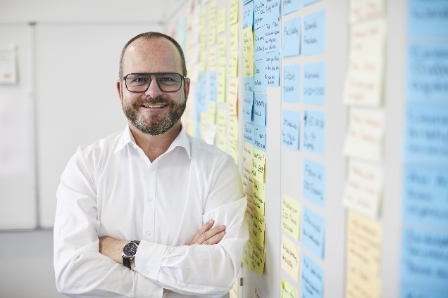  Dr. Gunther Wobser, President and CEO of LAUDA © Behrendt und Rausch | 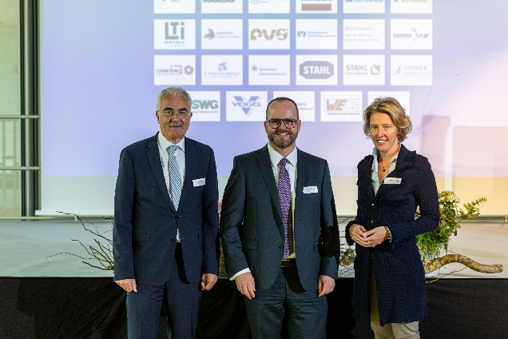  Guido Rebstock, Managing Director of Innovationsregion Hohenlohe e. V., Dr. Gunther Wobser, President and CEO of LAUDA, Dr. Stefanie Leenen, Chairwoman of Innovationsregion Hohenlohe e. V. (l. to r.) © Innovationsregion Hohenlohe e. V.

We are LAUDA – the world leader in precise temperature control. Our constant temperature equipment and systems are at the heart of important applications, contributing to a better future. As a complete one-stop supplier, we guarantee the optimum temperature in research, production and quality control. We are the reliable partner for electromobility, hydrogen, chemicals, pharmaceuticals/biotech, semiconductors and medical technology. We have been inspiring our customers for more than 65 years with our expert mentoring and innovative solutions – every day anew and all over the world.

Press contact
For the press, we are very happy to provide information about our company, the LAUDA FabrikGalerie and our projects in the field of innovation promotion, digitalization and idea management. We look forward to an open exchange with you - contact us!

ROBERT HORN CLAUDIA HAEVERNICK
Corporate Communications Manager Corporate Communications
T + 49 (0) 9343 503-162 T + 49 (0) 9343 503-349
robert.horn@lauda.de claudia.haevernick@lauda.de

