THINKING AHEAD FOR THE DIGITAL TRANSFORMATION

Dr. Gunther Wobser, President and CEO of LAUDA, new member of the BDA Digital Council

Lauda-Königshofen, June 2022 - Dr. Gunther Wobser, President and CEO of LAUDA DR. R. WOBSER GMBH & CO. KG, the world market leader for temperature control equipment and systems, has been appointed to the Digital Council of the Confederation of German Employers' Associations. The entrepreneur, author and lecturer now strengthens the 20-member council, consisting of thought leaders from family businesses, corporations, the tech industry, start-ups and academia. The chairpersons are former Siemens AG executive Janina Kugel and the CEO of WAREMA Renkhoff SE, Angelique Renkhoff-Mücke. Other prominent members include digital pioneer Christoph Bornschein, bestselling author Christoph Keese, and Industrie 4.0 thought leader Prof. Dr. Wolfgang Wahlster. The digital transformation of the world of work cuts across all industries and poses completely new questions and demands on society, employees and employers. The focus of the new Council member is on passing on his knowledge of innovation, providing impetus to society and the corporate world, and developing effective recommendations for action for politics and business from the perspective of SMEs. He is particularly interested in the professional exchange in the trusting round. The BDA Digital Council is always concerned with encouraging and empowering decision-makers from business and society to actively shape and accompany change.

"The appointment is a great honor and recognition for me. Challenges that a modern company of our time has to face require the development of new business models as well as innovative technologies and strategies," says Dr. Gunther Wobser. "Agility, flexibility, modern leadership and ambidextry - efficiently and flexibly expanding our core business consistently while at the same time systematically exploiting innovations and opportunities for the future - is a necessity in order to position one's own company for the future." The successful entrepreneur would like to bring his own experience to bear in Berlin in order to jointly master the challenges at the economic and socio-political level and to drive forward solutions to the problems of digital transformation.

About the BDA Digital Council
The Digital Council of the German Employers' Associations was founded in April 2019 and brings together personalities who deal with digital transformation in their respective professional contexts. They develop new business models as well as innovative technologies or concepts, conduct research along these topics and are key players in the social debate. These different perspectives and competencies are brought together in the BDA Digital Council to find solutions in an interdisciplinary and networked manner. The Confederation of German Employers' Associations is the leading social policy organization for the entire German economy. It represents the interests of one million companies with around 20 million employees across all sectors at national, European and international level and is thus the mouthpiece of German industry on the working world of the future.

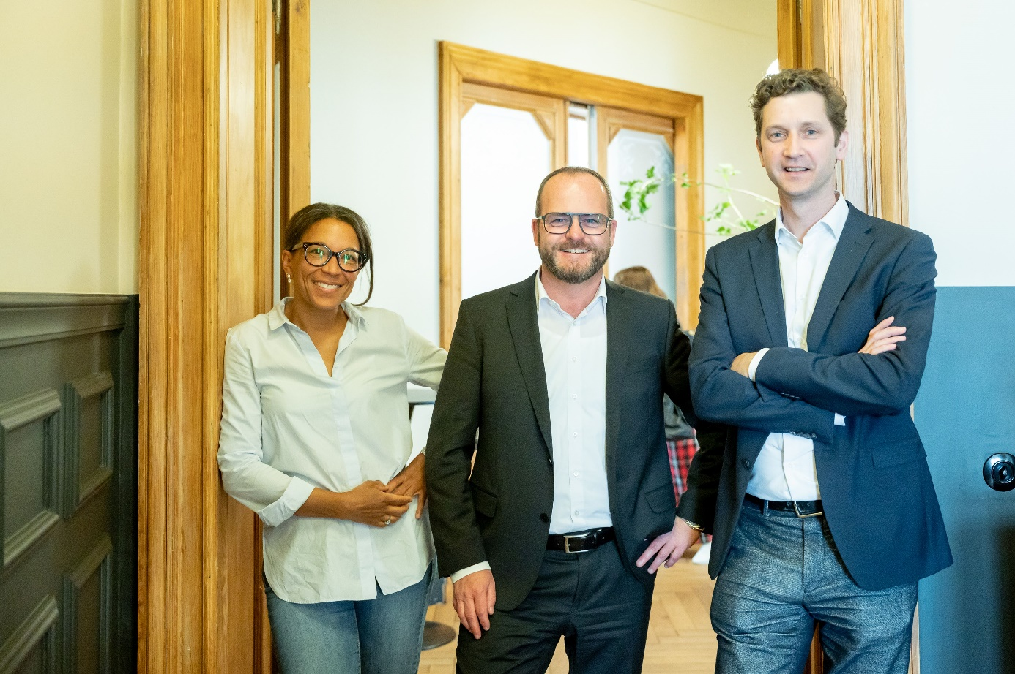
Dr. Gunther Wobser (in the midle)_Digitalrat_BDA © BDA/Christian Kruppa

LAUDA's President and CEO Dr. Gunther Wobser (center), shown here with Chairwoman Janina Kugel and Kristian Schalter, Head of Strategy and Future of Work at the BDA, has been appointed to the Digital Council of the Confederation of German Employers' Associations.

We are LAUDA – the world leader in precise temperature control. Our constant temperature equipment and systems are at the heart of important applications, contributing to a better future. As a complete one-stop supplier, we guarantee the optimum temperature in research, production and quality control. We are the reliable partner for electromobility, hydrogen, chemicals, pharmaceuticals/biotech, semiconductors and medical technology. We have been inspiring our customers for more than 65 years with our expert mentoring and innovative solutions – every day anew and all over the world.

Press contact
For the press, we are very happy to provide information about our company, the LAUDA FabrikGalerie and our projects in the field of innovation promotion, digitalization and idea management. We look forward to an open exchange with you - contact us!

ROBERT HORN CLAUDIA HAEVERNICK
Corporate Communications Manager Corporate Communications
T + 49 (0) 9343 503-162 T + 49 (0) 9343 503-349
robert.horn@lauda.de claudia.haevernick@lauda.de

