The right temperature worldwide

Vacuubrand chooses LAUDA LOOP
The thermoelectric circulation thermostat for quality assurance

Lauda-Königshofen, 8 September 2017 – The new, innovative LOOP L 250 thermoelectric circulation thermostat by LAUDA is proving its performance as an elegant all-rounder in quality assurance at VACUUBRAND. VACUUBRAND GMBH & CO. KG, from Wertheim, Germany, manufactures the most comprehensive range of vacuum generation, vacuum measurement and vacuum control products worldwide for coarse and fine vacuums in laboratories.
When certain workpieces are measured for dimensional accuracy during quality assurance, the temperature must remain constant to ensure comparability. Since the ambient temperature in the production hall varies considerably at different times of the year, the measuring equipment and workpieces are maintained at a constant temperature of 19 °C on a copper plate with water flowing through it. For this purpose, the LAUDA LOOP L 250 is switched on via an external timer at five am to pre-heat the plate. The device is switched off automatically at six pm. "The LOOP meets our requirements perfectly," says Martin Scheurich, who is responsible for technical services at VACUUBRAND. "It is extremely compact and works without any refrigerant whatsoever – that saves us a lot of technical testing, which would otherwise be necessary". The device is less maintenance-intensive and highly energy-efficient; even though it runs for 13 hours per day." The LAUDA LOOP has been available on the market since spring 2017, making it the most recent product development from LAUDA in Lauda-Königshofen.
This external thermostatic circulator was developed for the requirements of modern laboratory work processes:
The highly flexible thermoelectric circulation thermostat accurately maintains a constant temperature between
4 and 80 °C. The air-cooled LAUDA LOOP is ideal for laboratories with limited space, thanks to its compact design and low noise emissions, whilst still achieving impressive cooling performance. The smaller version, the L 100,
has an output of 120 Watts at 8 kilogram, while the larger L 250 offers 250 Watts at 12 kilogram. With the LAUDA LOOP, LAUDA is the first leading manufacturer of thermostatic circulators to employ Peltier technology without the use of refrigerant. This provides benefits in operation and maintenance, in safety of the work processes and the environment.
The LAUDA LOOP is used primarily in laboratory applications in a wide variety of industries: from bio-technology to life sciences, as well as the chemical industry, pharmaceuticals and medical technology, and even production.
About LAUDA
We are LAUDA - The world leader in precise temperature control. Our Constant temperature equipment and Heating and cooling systems are at the heart of many applications. As a full-service provider we guarantee the optimum temperature in research, production and quality control. We are the trusted partner, particularly in the fields of automotive, chemical/pharmaceutical, semiconductor and laboratory/medical industries. For over 60 years we have been inspiring our customers with our competent consulting and innovative, environmentally-friendly concepts, anew every day – globally.

Figure 1: The LAUDA LOOP circulation thermostat operates within the 4 to 80 °C range using the latest Peltier technology. The two air-cooled devices, L 100 and L 250, have a cooling capacity of 120 and 250 Watts.
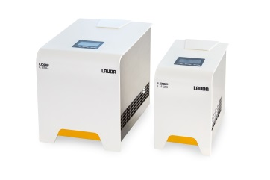

Figure 2: The LAUDA LOOP can be used for the most varied of applications in laboratories, thanks to its small size and low weight. The menu-driven interface is navigated using three keys, and is displayed on a bright, high-contrast OLED screen.
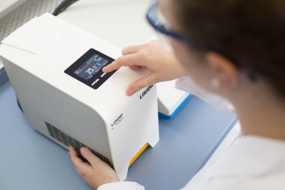

Direct contact at LAUDA:
José-Antonio Morata
Manager Media and Events
Tel.: +49 (0) 9343 503-380
Fax: +49 (0) 9343 503-4380
E-mail: jose.morata@lauda.de

