The right temperature worldwide

LAUDA impresses with LAUDA LOOP at Forum LABO 2017
Future-oriented innovations for temperature control solutions in Paris
Lauda-Königshofen, March 31, 2017 – For LAUDA, the world's leading manufacturer of temperature control devices and systems, this year's Forum LABO, which took place in Paris from March 28 to 30, 2017, has been very successful with numerous interesting technical discussions. A very special highlight for the trade visitors was the presentation of LAUDA LOOP, a novel thermoelectric circulation thermostat based on Peltier technology. By means of a current flow, the LAUDA LOOP temperature is generated by semiconductors and can be used for either heating or cooling, simply by reversing the current direction. The air cooled LAUDA LOOP device types L 100 and L 250 are suitable for external applications in a temperature range of 4 to 80 °C. For the pharmaceutical industry and biotechnology sector, LAUDA LOOP provides real added value thanks to its compact and space-saving design. LAUDA LOOP can be flexibly used for the temperature control thermostating of refractometers, bioreactors, electrophoresis chambers or for sample preparation. In industrial cooling applications, LAUDA has presented the Ultracool UC Mini compact process circulation chiller for cooling outputs between 2 and 5 kilowatts. The size of the device has been reduced considerably compared to the established previous models. The square design with a side length of only 64 centimeters allows the customer to spatially position the Ultracool UC Mini in a very flexible manner. The impressive product portfolio at the fair was rounded off by the LAUDA PRO product line. For the first time, there are powerful bath thermostats for exact, internal temperature control from -100 to 250 °C and efficient circulating thermostats for dynamic heating and cooling of external applications from -45 to 250 °C. During the three exhibition days in Paris, these new devices also underlined the new benchmark for uncompromising temperature control from LAUDA.

Picture 1: A special highlight for the trade visitors of the LABO Forum – the new LAUDA LOOP.
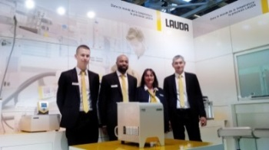
Picture 2: Future-oriented innovations for temperature control solutions in Paris.
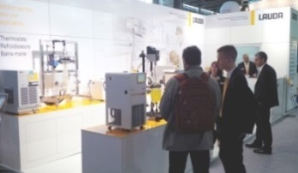

Direct contact at LAUDA:
José-Antonio Morata
Manager Media and Events
Tel.: +49 (0) 9343 503-380
Fax: +49 (0) 9343 503-4380
E-mail: jose.morata@lauda.de

