LAUDA Scientific GmbH –
A change in Sales management

Lauda-Königshofen, 4th April 2016 – Philipp Neumann Dipl.Ing (FH) has taken over the Sales management of the Measuring instruments of LAUDA Scientific GmbH, a subsidiary of LAUDA DR. R. WOBSER GMBH & CO. KG since the 1st April 2016. He replaces the long-term Sales manager, Dr. Armin Hofmann, who has since taken retirement.
Philipp Neumann was employed by LAUDA DR. R. WOBSER GMBH & CO. KG as Sales manager for Asia/Middle East from 2009, and was primarily responsible for the LAUDA Constant temperature equipment. He moved to the subsidiary in August last year, in order to work hand-in-hand with Dr. Hofmann during the transition period.
LAUDA Scientific develops, manufactures and distributes devices for determining the viscosity, surface tension and interfacial tension of polymer solutions, oils and tensides. For example, the Duo.Visc double Ubbelohde viscometer can be used to carry out two independent viscosity measurements in separately controlled thermostat vessels, with a very small footprint and thermally insulated baths, or the boundary stress and surface tension can be determined on-site without the need for a computer using the TD4 automatic tensiometer.
Restructuring of the international sales network and the development of new markets will enable LAUDA Scientific GmbH to meet the future challenges of a global market and to support its customers in satisfying the
ever-growing demands.
Dr. Gunther Wobser, President & CEO of the family-owned LAUDA company, adds: “Philipp Neumann is a member of staff who is very familiar with Measuring instruments and we are pleased that we have been able to acquire his services for our new subsidiary.”

Visit LAUDA Scientific at analytica fair, Munich, Hall A2, Stand 427.
Image: (LAUDAScientific_Philipp-Neumann.jpg)
Philipp Neumann is the new Sales manager at LAUDA Scientific.

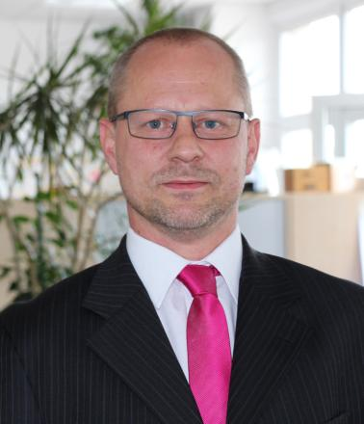

LAUDA direct press contact:
José-Antonio Morata
Manager Media and Events
Tel.: +49 (0) 9343 503-380
Fax. +49 (0) 9343 503-4380
E-mail: jose.morata@lauda.de

