The right temperature worldwide

The new standard for temperature control without compromise
The new LAUDA PRO bath and circulation thermostats
Lauda-Königshofen – Correct temperature control is a critical requirement for countless applications in research laboratories and industrial production. Progressive technical development is exponentially increasing the demands placed upon temperature control technology. Demand for universal devices is quickly giving way to the need for solutions to specific challenges. With the market introduction of the new product line of bath and circulation thermostats, LAUDA PRO, the worldwide leading manufacturer of constant temperature equipment and systems once again proves its ability to innovate while simultaneously meeting growing market demand for individual products and more variety.
Powerful bath thermostats for precise internal temperature control from -100 to 250 °C and efficient circulation thermostats for dynamic heating and cooling of external applications from -45 to 250 °C underscore the orientation of the LAUDA PRO product line to a wide variety of applications. Three high-temperature and six low-temperature thermostats with different bath volumes of 10, 20 and 30 liters are available for internal temperature control. All devices guarantee the highest level of temperature stability and homogeneity. One heating circulation thermostat and two cooling circulation thermostats ensure 100 percent efficiency in external applications. Extremely low filling volume combined with a powerful vario flex pump facilitate dynamic temperature control with minimum energy consumption.
The operating concept also allows for individuality in a big way. The user may select between two completely redesigned LAUDA PRO control units. The Base model option provides the user with all of the important parameters on an ultra-bright and high contrast OLED display. Individual program items are easy to control using softkeys and cursor. Five available languages (English, German, French, Spanish and Italian) and clear menu guidance enable the intuitive and confident operation of the Base control unit. The functionality of a second model developed by LAUDA, the Command Touch operating unit, is even more user-friendly and comprehensive. The Command Touch model is equipped with a large and brilliant 5.7” multi-touch screen and provides the option to individually organize the menue icons. This makes it possible for the user to structure the control menu according to individual and very specific requirements. Other benefits include a zoomable graphics display and eight languages in total (the Command Touch control unit additionally offers menu guidance in Chinese, Japanese and Russian). Setpoints and actual values of key parameters are clearly displayed on the screen. Swipe and zoom features make the visualization of temperature profiles and individual parameters easy. The popular smartphone “finger touch principle” even works with lab-gloves, a special comfort appreciated by lab professionals.
Whether the Base or Command Touch model, both operating consoles are removable and provide users with flexibility in terms of device positioning and control. An optional cable length of up to 50 meters provides an extremely high degree of flexibility for the set-up of LAUDA PRO devices.
Environmental awareness also played a role in the development of the new product line. All cooling circulation thermostats purchased in the European Union and Switzerland are supplied with natural refrigerants. This makes the new LAUDA PRO bath and circulation thermostats the new standard for temperature control without compromise.

Image: Discover the new standard in no-compromise temperature control: the new LAUDA PRO bath and
circulation thermostats.

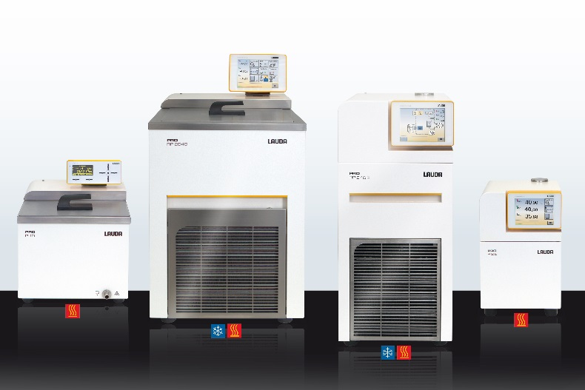

Direct contact at LAUDA:
José-Antonio Morata
Manager Media and Events
Tel.: +49 (0) 9343 503-380
Fax: +49 (0) 9343 503-4380
E-mail: jose.morata@lauda.de

