The right temperature worldwide

Karlheinz Wobser celebrates his 80th birthday
Karlheinz Wobser, who is well known as the long-serving former President & CEO of LAUDA and for his service to the community, celebrates his 80th birthday on June 28, 2016.

Karlheinz Wobser was born in Dresden on 28 June 1936 as the first child of Dr. Rudolf Wobser and Dorothea
Wobser, née Nitzki. In 1942, the 4th year of the war, he started school in Medingen around 20 kilometers away, where his father had been given the task of setting up an apparatus engineering department in the Medingen testing instrument factory. Wobser frequently had to throw himself into the roadside ditch to evade attacks from low-flying aircraft on his way to school, a distance of approximately 1.5 kilometers. The night of 13 February 1945, when Dresden was reduced to ash and rubble, was a traumatic experience. The communist-dominated school system in the Soviet-occupied zone after the end of the war in 1945 also made its mark on the education of the young Karlheinz, who stayed at Medingen elementary school until 1950, learned Russian and was a "Young Pioneer". He passed the Abitur (high-school diploma) at Dresden-Süd high school in 1954. Like most others, Wobser was also a member of the so-called "Free German Youth (FDJ)" and the "Sport and Technology Association (GST)". He studied mechanical engineering at Dresden Technical University from the fall of 1954, specializing in precision mechanics. During an internship semester, Wobser learnt practical skills at the Medingen testing instrument factory, amongst other places.
In May 1955, his parents took the decision to leave the GDR, since the political pressure on his father had been steadily increasing. During an internship in Berlin-Teltow organized especially for this reason, he managed to take a total of 13 suitcases to relatives in the west of Berlin, which had not yet been divided by a wall. The Wobser family escaped to West Berlin in August 1955 and took a flight to Frankfurt-on-Main one month later. The family found accommodation in Schwenningen on the Neckar for a while. Karlheinz Wobser worked as a mechanic in the Wigo factory in Schwenningen until March 1956, whereas the rest of family had moved to Burlafingen near Neu-Ulm in the meantime. During this time, his father was on a nationwide search for investors and had found a site and potential customers for his own company and met with interest from the city government of Lauda as well as the factory owners Erich Widmann and his friend Paul Hagspiel. The measuring instrument factory of LAUDA DR. R. WOBSER KG, which celebrates its 60th anniversary this year, was founded on 1 March 1956.

In the meantime, Karlheinz Wobser was threatened with deportation back to the GDR after the failure of his admission proceedings for the Federal Republic of Germany. However, he obtained an identity card, and therefore Federal German citizenship, more or less by chance several years later. The foregoing uncertainties were a major reason why Wobser did not resume his studies. Nevertheless, he played a key role in the development of the new LAUDA measuring instrument factory of his father. As one of the first employees, he learned the theoretical and technical basis of refrigeration engineering, amongst other things. The fact that low-temperature thermostats from LAUDA gained an excellent reputation throughout the world in the years that followed is mainly down to Karlheinz Wobser.
Karlheinz Wobser met his future wife, Gudrun Schüssler from Tauberbischofsheim, in January 1957. The wedding took place four years later in October 1961. They had three children, Andrea (1962), Gabriele (1963) and Ulrike (1964). All three daughters have their own families and children in the meantime. In addition to this, two of his daughters work at the company. A continuous upward trend now began for the young company with a newly developed and revolutionary program, more and more employees were taken on and new construction was followed by new construction. Wobser was the technical director of the company from 1957 to 1977. When the company founder, Dr. Rudolf Wobser, died on 17 June 1977 at the age of only 66 after a short serious illness, his two sons, Karlheinz Wobser and Dr. Gerhard Wobser, became managing directors of the LAUDA company. Karlheinz
Wobser retired at the end of 2002. His nephew, Dr. Gunther Wobser, who currently runs the family-owned company in the third generation, was appointed as the new President & CEO. He ran the company together with his
father, Dr. Gerhard Wobser, until 2010, when the latter also retired after 39 years.
Apart from his work and family, numerous honorary activities have shaped the life of Karlheinz Wobser. He was member of the executive committee of the Sparkasse Tauberfranken bank from 1985 to 2008, a lay commercial judge of the Chamber for Commercial Affairs at Mosbach Regional Court from 1996 to 2004 and a member of the Representatives' Assembly of the AOK health insurance provider for many years. He is also a member of several clubs in Lauda and has done a great deal for the Lauda tennis club and the Bauland aviation sports club as a long-standing committee member. He has been a member of the Glashofen-Neusaß golf club near Walldürn for several years. Apart from playing golf, other hobbies of the birthday boy include traveling, e.g. river cruises, playing the accordion and keyboards, the upkeep of his koi fish ponds, sports boating on the lakes of Mecklenburg, especially with his four grandchildren, as well as painting, which he took up recently. He celebrated his golden wedding anniversary with his wife Gudrun five years ago.

Wobser followed the reconstruction of the Frauenkirche in his hometown of Dresden with great interest and made substantial donations to the friends' association, of which he is still a member. As a result, Wobser was also a guest at the dedication ceremony of the Dresden Frauenkirche in October 2005. "Despite all the difficulties, my childhood in Medingen was a happy time, even if it has been romanticized by memory", says Wobser, who continues to maintain contact not only with his old home but also with old school friends after he had great pleasure in attending the first class reunion in the fall of 1985, i.e. still during the time of the GDR. "Live and let live” is a key guiding principle for Wobser, which has him helped in the eight decades of his life and has always been very important to him.

Image: Karlheinz Wobser celebrates his 80th birthday on 28 June 2016.
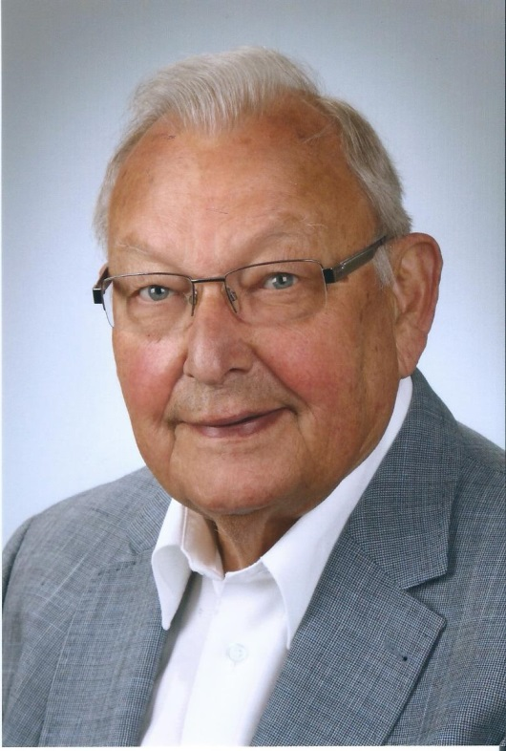

Direct contact at LAUDA:
José-Antonio Morata
Manager Media and Events
Tel.: +49 (0) 9343 503-380
Fax: +49 (0) 9343 503-4380
E-mail: jose.morata@lauda.de

