FUTURE INVESTMENT IN COOLING SOLUTIONS WITHOUT REFRIGERANTS

LAUDA invests in start-up for sustainable magnetic cooling technology

Lauda-Königshofen, April 4, 2023 – Together with other investors, temperature control specialist LAUDA has invested in the start-up MAGNOTHERM. With this round of financing, concluding at over 5 million EUR, the multiple award-winning start-up plans to start serial production of its first sustainable refrigerator. LAUDA has been following the development of the promising start-up from Darmstadt since 2019, through its innovative subsidiary new.degree GmbH. The two companies now want to utilize this longstanding relationship and the latest investment of 300,000 EUR to identify strategic reference points for subject areas and projects of shared interest.

MAGNOTHERM was founded out of the Technical University of Darmstadt by the current managing directors, Dr. Maximilian Fries and Timur Sirman, and develops sustainable cooling solutions without the use of conventional industrial refrigerants – which are often harmful to the climate. The start-up uses a temperature-active, magnetic metal to cool a water mixture. In principle, this revolutionary technology can be used for any type of cooling – an advantage that has piqued the interest of the world market leader for precise temperature control: “Equipment from LAUDA is used to control temperature in the applications and processes of major future industries around the world,” explains Dr. Mario Englert, who as Chief Financial Officer is responsible for investments. President and CEO, Dr. Gunther Wobser added: “As the world market leader, we want to make the world a better place with precise temperatures – that is our vision and what we put into practice every day. In the future, energy-efficient systems will be needed that conserve resources and minimize harmful emissions. MAGNOTHERM has taken an important step in the right direction, which complements our technological expertise as a world market leader. With our investment, we are laying the foundation stone for a successful collaboration between the start-up and industry, and can benefit from one another.”
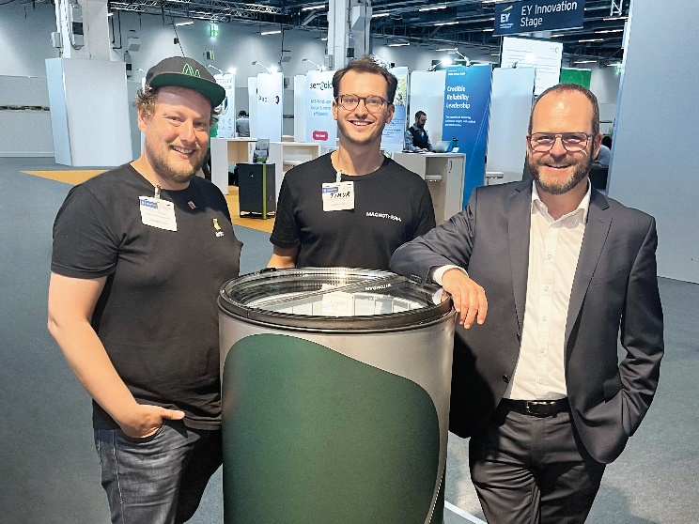
From left to right: Dr. Maximilian Fries and Timur Sirman from MAGNOTHERM,
Dr. Gunther Wobser, President & CEO of LAUDA © MAGNOTHERM

We are LAUDA – the world leader in precise temperature control. Our constant temperature equipment and systems are at the heart of important applications, contributing to a better future. As a complete one-stop supplier, we guarantee the optimum temperature in research, production and quality control. We are the reliable partner for electromobility, hydrogen, chemicals, pharmaceuticals/biotech, semiconductors and medical technology. We have been inspiring our customers for more than 65 years with our expert mentoring and innovative solutions – every day anew and all over the world.

In our company, we always go one step further. We support our employees’ development and are constantly developing ourselves: to create a better future together.

Press contact
We are more than happy to make prepared information about our company, the LAUDA Factory Gallery and our projects in the area of innovation promotion, digitalization and idea management available to the press. We look forward to hearing from you – just give us a call!

CLAUDIA HAEVERNICK
Head of Corporate Communication
T + 49 (0) 9343 503-349
claudia.haevernick@lauda.de

LAUDA DR. R. WOBSER GMBH & CO. KG, Laudaplatz 1, 97922 Lauda-Königshofen, Deutschland/Germany. Limited partnership: Headquarters Lauda-Königshofen, Registration court Mannheim HRA 560069. General partner: LAUDA DR. R. WOBSER Verwaltungs-GmbH, Headquarters Lauda-Königshofen, Registration court Mannheim HRB 560226. Managing Directors: Dr. Gunther Wobser (President & CEO), Dr. Mario Englert (CFO), Dr. Ralf Hermann (CSO), Dr. Marc Stricker (COO)

